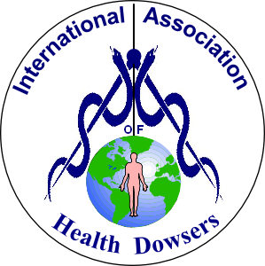 | International Association of Health Dowsers  &  Association of Energy Therapists  2017  CONVENTION  Runnymede-on-Thames Hotel  Windsor Road, Egham, Surrey, TW20 0AG

Saturday 21st October 2017
10.15am – 5pm (registration from 9.45am)

This luxury venue provides a beautiful riverside setting our event.
We have four knowledgeable speakers leading a diverse and experiential learning opportunity.
As a participant you will benefit from this amazing gathering of experts and therapists.
In addition, you will also enjoy lunch in this stunning hotel’s restaurant.
This event is offered for an unbeatable price of
£75 for AET, IAHD & ACTTS members and £85 for non-members.
We also have a special offer if you book with a friend!
Once again, this exceptional offering is made possible by the organisers subsidising the event.

To book your place

Complete the form below and return it along with a cheque made payable to the “Association of Energy Therapists” to Keith Harmon, 52, Helen Avenue, Feltham, Middlesex, TW14 9LB by the 21st September 2017

AFTER THIS DATE PLEASE TELEPHONE KEITH on 020 8751 0417 TO CHECK AVAILABILITY
We regret for contractual reasons we cannot accept anyone without prior booking

Terms and Conditions regarding cancellation of a booking. In order to protect the finances of both organisations, it is necessary to introduce terms that are consistent with terms of cancellation imposed on us by most providers of conference venues. For this event cancellations will be dealt with as follows; Cancellation up to one month prior to the event - 90%. Cancellation within one month, but more than one week prior to the event - 50%. Cancellation made within one week of the event - no refund.
The organisers, AET & IAHD, reserve the right to substitute speakers should those advertised be unavailable on the day.

REGISTRATION FORM

Name(s): |  | Number Attending on  21st October 2017
Address: | Member(s)  IAHD/AET/ACTTS  (please circle as appropriate) | @ £75  (per person)
Special offer
@ £140
(2 people booking together)
Postcode | Non-Member(s) | @ £85  (per person)
Telephone: |  | Special offer  @ £150  (2 people booking together)
E-Mail: |  | Total Enclosed
May we acknowledge your booking by email?  (if not and you require confirmation, please enclose a stamped addressed envelope) |  | Yes / No
Do you have any Dietary Requirements? Yes / No (if yes give details)
May we contact you to advise you about future IAHD / AET / ACTTS events? |  |  | Yes / No
As this is expected to be a very popular event please reserve your place by registering as soon as possible
for further details please contact Keith Harmon 020 8751 0417 e-mail: nrgft@hotmail.com.
Introducing your speakers …..

Karen French - Sacred Geometry: It’s Significance And Potential Within Your Reality
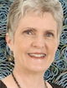 | Without Geometry, there would be no time, no space, and no possibility of your existence. Your thoughts, actions, and creativity rely on Geometry. Learn about the meaning and purpose of five essential, yet simple, Geometric Shapes that are fundamental to the construction of reality, and a Universal Model called the ‘Gateway to the Heavens’. Hear why they have been used down the Centuries, as potent symbols and powerful tools in all cultures, particularly when used with a Sacred Intent. Sacred Geometry is evident in every discipline, and can be used in a wide variety of ways, in everything you do, including Healing and Dowsing. We will be doing a few very simple exercises to really appreciate the dynamics and the significance of these shapes.
Angela Delglyn - Questions are the Answers  - writing a working plan for maintaining your own health |  |  | 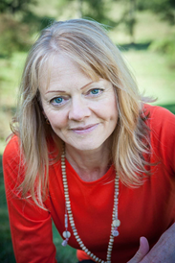
“Dowsing for your health doesn’t have to be about guess work; it can and should take on a more systematic approach. Having a foundation model built on key factors is essential if you’re to find what you’re looking for. There are several dimensions to such a model, and you can go deeper, but I aim to provide a simple structure that anyone can utilise as they work towards finding their own balance”
Alessandro Ferullo - Qi Gong For Health

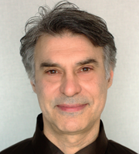 |  | QiGong (Chi Kung) is the ancient Art of Energy Work via exercise, which has been keeping the Chinese Nation healthy for Millennia. Hua Gong is a 1000 year old Chinese form, which Wimbledon based Alessandro, who has 20 years of experience, will be teaching us. He will give delegates a brief introduction to Hua Gong, and the benefits and ways of re-balancing and re-charging our Energy, and learn how to sense the energy in our body and around us. Then he will invite everyone to get up on their feet, to join in one of the most widely practiced health Hua Gong sets. This set utilises correct breathing, to regulate the flow of energy, to promote excellent health. The Session will end with a short question and answer opportunity, if time permits. This is an audience participation Workshop, so come along and enjoy!
Avril Holland – The Legalities Of Running A Complementary Therapy Practice
With over 25 years of experience, as a Therapist and holder of a Masters Degree in Medical Law and Ethics, Avril will be exploring issues around Consent, Treating Minors, Records, Reports, Record Keeping, and Data Protection.  Avril will be facilitating a discussion about the Legal aspects of running any Complementary Therapy Practice.  This is a very important subject for us all, and some of you may have come across some Legal problems, whilst setting up your Therapy Practice. To help you, Avril has offered to answer questions on your own problems, or concerns. If you would like to take this wonderful opportunity, please email her the details, by the Sunday 1st October 2017, to avril.holland@gmail.com |  |  |  | 